**Summer Internship Report**

RCS Based Chat System

By Tushar Gautam

May-Jun 2020

horizontal line

# Acknowledgment

I would like to express my gratitude to Samsung Electronics for giving me this opportunity to do my summer 2020 internship training.

Throughout this training, I am lucky to have guidance and monitoring from my mentor Mr. Raja Bollam. I also would like to thank Mr. Chaehoon Kim and Mr. Ram Saralaya from the HR department for being available to help us throughout the internship.

# Introduction

# 5G overview:

With the world becoming digital 4G networks cannot cope up with increasing demands of faster speed and lower latency, this is where the need for 5G comes in shaping the new generation of mobiles. New Multi-access Edge Computing (MEC) deployments and better network slicing hold the backbone of 5G and IP services which start inspiring Operators to deploy innovating technologies and develop new commercial principles to deliver network economic optimization such as RCS messaging, Cloud XR, etc.

**IMS:**

The IP Multimedia Subsystem (IMS) is a reference architecture defined by the 3rd Generation Partnership Project (3GPP) for delivering IP multimedia communication services. Originally mobile phones have provided voice call services over a circuit switch style network, rather than strictly over an IP packet switch network. With new alternative methods of communications such as delivering voice (VoIP) the IMS provides an architectural framework standardization.

IMS uses [IETF](https://en.wikipedia.org/wiki/IETF) protocols wherever possible, e.g., the [Session Initiation Protocol](https://en.wikipedia.org/wiki/Session_Initiation_Protocol) (SIP).

**RCS:**

Rich Communication Services (RCS) is a communication protocol between network carriers, aiming at replacing SMS messages with a text-message system that is faster, richer, and provide app-like experience, without the investment on resources of an app. It is a part of IMS and signaling is done through SIP (Signal Initiation Protocol).

# Project

The internship project was on developing one to one RCS based Chat system using OpenSips as the backbone.

**Overview:**

Opensips is open-source software that provides a SIP server implementation thus could act as a SIP registrar and proxy server while communication between SIP-based user agents takes place. Python Sockets library can be used to generate SIP formatted messages and can be used as user agents. After registration and initiation (Invite) reply user agent can form a direct connection to the other user agent using information from the reply and start a normal TCP connection (process messaging, file transfer, etc) and end the session.

**Registration:**

When a user agent starts his connection for the first-time registration to the registrar takes place which stores mapping from his contact (such at tel no. / sip user-id) to his communication address (IP, port).

Here a registration diagram example:

User Alex joins the connection and registers to the SIP server by sending a REGISTER message which in end receives a confirmation by ACK reply.

Later, Bob also joins in the connection and gets registered.

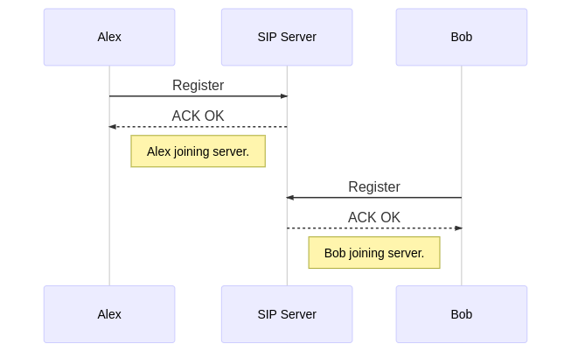

**Invitation:**

When a user wants to start messaging to another user he sends and INVITE other-user-id to SIP proxy which converts other-user-id from its mapping to IP and forwards the message to the other user, who replies back to SIP proxy with an ACK to confirm start the connection. This is ack is forwarded from proxy to user back and contains information about the actual address (IP, port) of the other user. This information can now be used to form a direct connection to the other user.

Here is an example of the process:

Alex and Bob have both joined the server now Alex wants to start a chat with bob he sends an INVITE bob-user-id to SIP server and following communication takes place.

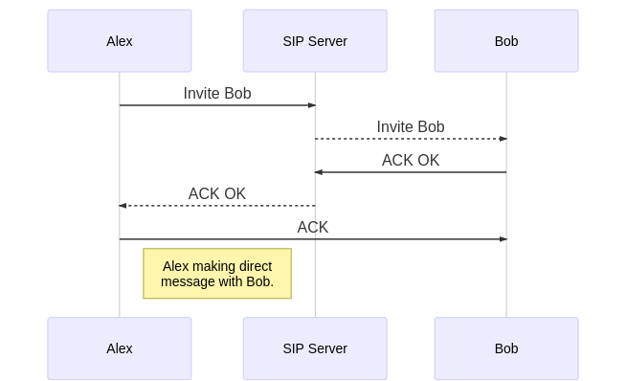

# Bibliography:

* For more details on the project: [Github Repo of the project](https://github.com/tusg25/1on1-chat-using-sip).
* <https://opensips.org/>
* <https://tools.ietf.org/html/rfc3261>